JAVA Conceptual Questions

Q> What is the difference between continue and break statement?
Ans: break and continue are two important keywords used in Loops. When a break keyword is used in a loop, loop is broken instantly while when continue keyword is used, current iteration is broken and loop continues with next iteration.
In below example, Loop is broken when counter reaches 4.
for (counter = 0; counter<10; counter++)
system.out.println(counter);

if (counter == 4) {

break;
}

}

In the below example when counter reaches 4, loop jumps to next iteration and any statements after the continue keyword are skipped for current iteration.

for (counter = 0; counter < 10; counter++)
system.out.println(counter);

if (counter == 4) {

continue;
}
system.out.println("This will not get printed when counter is 4");
}

Q>What is the difference between double and float variables in Java?
Ans:-

BASIS FOR  COMPARISON | Java Float | Java Double
Definition | The float data type is a single-precision 32-bit | The double data type is a double-precision 64-bit
Usage | less precision | More precision
Benefits | Extensive support libraries.  Open source and community development. | More features for web development and web-focused
Storage | The float needs 32-bit storage(It  Just take 4 bytes to store a variable) | Double needs 64-bit storage(It  takes 8 bytes to store a variable)
Precision | Float precision is 6 to 7 decimal digits | Double can provide precision up to 15 to 16 decimal points.
Range | Float is having a lower range when compared to double. | Double has a higher range.

Though both Java float and Double can represent floating-point numbers, we can consider a couple of things to choose between Java float and double. Though both Java float vs Double is approximate types, use double if you need more precise and accurate results. Use float if you have memory constraint because it takes almost half as much space as double. If your numbers cannot fit in the range offered by float, then use double. Though be careful with floating-point calculation and representation, don’t use double or float for monetary calculation, instead use Big Decimal.
That’s all on the difference between float and double in Java. Remember, by default, floating-point numbers are double in Java; if you want to store them into a float variable, you need to either cast them explicitly or suffice them using the ‘f’ or ‘F’ character.

Q> what is JDK , JRE and JVM(VM ware,IBM, HCL)
Ans:-
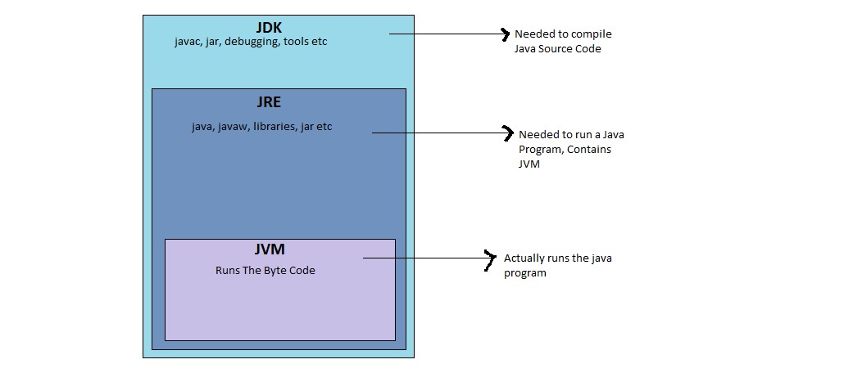

Q>How can you generate random numbers in Java?
Ans :- using java.util.Random class

- For using this class to generate random numbers, we have to first create an instance of this class and then invoke methods such as nextInt(), nextDouble(), nextLong() etc using that instance.
- We can generate random numbers of types integers, float, double, long using this class.
- We can pass arguments to the methods for placing an upper bound on the range of the numbers to be generated. For example, nextInt(6) will generate numbers in the range 0 to 5 both inclusive.

// A Java program to demonstrate random number generation
// using java.util.Random;
import java.util.Random;

public class generateRandom{

public static void main(String args[])
{
// create instance of Random class
Random rand = new Random();

// Generate random integers in range 0 to 999
int rand_int1 = rand.nextInt(1000);
int rand_int2 = rand.nextInt(1000);

// Print random integers
System.out.println("Random Integers: "+rand_int1);
System.out.println("Random Integers: "+rand_int2);

// Generate Random doubles
double rand_dub1 = rand.nextDouble();
double rand_dub2 = rand.nextDouble();

// Print random doubles
System.out.println("Random Doubles: "+rand_dub1);
System.out.println("Random Doubles: "+rand_dub2);
}
}

Output:
Random Integers: 547
Random Integers: 126
Random Doubles: 0.8369779739988428
Random Doubles: 0.5497554388209912

Q> what is the difference between hashmap and hashtable (wipro, J & J, Talentica )
Ans :- There are several differences between HashMap and Hashtable in Java:

Hashtable is synchronized, whereas HashMap is not. This makes HashMap better for non-threaded applications, as unsynchronized Objects typically perform better than synchronized ones.
Hashtable does not allow null keys or values. HashMap allows one null key and any number of null values.
HashMap is not an ordered collection which means it does not return the keys and values in the same order in which they have been inserted into the HashMap

Code for HashTable

publicclass HashTableExample {
publicstaticvoid main(String args[]){

Hashtable<Integer,String> ht=new Hashtable<Integer,String>();

ht.put(100,"pune");
ht.put(101,"mumbai");

System.out.println(ht.get(100));
System.out.println(ht.get(101));
}

}

Q> What is Byte Code? (sears,,bmc)
Or
What gives java it’s “write once and run anywhere” nature?
or
What makes Java Platform independent(bmc)
Ans:- All Java programs are compiled into class files that contain bytecodes. These byte codes can be run in any platform
and hence java is said to be platform independent.

Q> Expain the reason for each keyword of public static void main(String args[])? (infosys, CTS, PTC, Avaya, Wipro, Amdocs)
Ans:- public- main(..) is the first method called by java environment when a program is executed so it has to accessible from java environment. Hence the access specifier has to be public.
static: Java environment should be able to call this method without creating an instance of the class , so this method must be declared as static.
void: main does not return anything so the return type must be void
The argument String indicates the argument type and arg is an array for string given during command line.

Q> What are the differences between == and .equals() ? ( xpanxion, media ocean, cts, scale arc, synerzip, talentica, Wipro, HCL, TechM, Mphasis, TCS)
Or
what is difference between == and equals
Or
Difference between == and equals method
Or
What would you use to compare two String variables, the operator == or the method equals()?
Or
How is it possible for two String objects with identical values not to be equal under the == operator?
Ans:-
The == operator compares two objects to determine if they are the same object in memory i.e. present in the same memory location.
It is possible for two String objects to have the same value, but located in different areas of memory.
== compares references while .equals compares contents. The method public boolean equals(Object obj) is provided by the Object class and can be overridden.
The default implementation returns true only if the object is compared with itself, which is equivalent to the equality operator == being used to compare aliases to the object. String,
BitSet, Date, and File override the equals() method. For two String objects, value equality means that they contain the same character sequence. For the Wrapper classes, value equality means that the primitive values are equal.

Example:-
--------
public class EqualsTest {

public static void main(String[] args) {

String s1 = "abc"; //this may or
String s2 = s1;
String s5 = "abc";
String s3 = new String("abc");
String s4 = new String("abc");
System.out.println("== comparison : " + (s1 == s5));
System.out.println("== comparison : " + (s1 == s2));
System.out.println("Using equals method : " + s1.equals(s2));
System.out.println("== comparison : " + s3 == s4);
System.out.println("Using equals method : " + s3.equals(s4));

}
}

Output
-----------
== comparison : true
== comparison : true
Using equals method : true
== comparison : false
Using equals method : true

Note :-
String a = "abc";
May or may not create a new String object.
If a String object with the literal "abc" already exists the reference 'a' will only point to it.
Since String objects are immutable.
Where as,
String a = new String("abc");
will always create a new Sting object.

Q> What if the static modifier is removed from the signature of the main method? (xpanxion, synechron, 3i infotech, Aftek )
Or
What if I do not provide the String array as the argument to the method?
Ans:-
Program compiles. But at runtime throws an error “NoSuchMethodError”.

Q> What is the difference between final, finally and finalize? What do you understand by the java final keyword? (bmc, infy, hsbc)
Or
What is final, finalize() and finally?
Or
What is finalize() method?
Or
What is the difference between final, finally and finalize?
Or
What does it mean that a class or member is final?
Ans:-
final – declare constant
finally – handles exception
finalize – helps in garbage collection

Q>Describe the principles of OOPS ( synerzip, entity data, CTS, persistent, caterpillar, j&J, synchrony, sunguard, cybage, bitwise )
Ans:- There are three main principals of oops which are called Polymorphism, Inheritance and Encapsulation.

Q>Explain the Polymorphism principle. Explain the different forms of Polymorphism.( all the companies )
Ans:- Polymorphism in simple terms means one name many forms. Polymorphism enables one entity to be used as a general category for different types of actions. The specific action is determined by the exact nature of the situation.
Polymorphism exists in three distinct forms in Java:
• Method overloading
• Method overriding through inheritance
• Method overriding through the Java interface

Q> In System.out.println(), what is System, out and println? ( hsbc, sears, xpanxion, cybage)
Ans:- System is a predefined final class, out is a PrintStream object and println is a built-in overloaded method in the out object.

Q> What are Java Access Specifiers?(allSccripts, talentica,Cybage)
Or
What is the difference between public, private, protected and default Access Specifiers?
Or
What are different types of access modifiers?
Ans:- Access specifiers are keywords that determine the type of access to the member of a class. These keywords are for allowing
privileges to parts of a program such as functions and variables. These are:
• Public : accessible to all classes
• Protected : accessible to the classes within the same package and any subclasses.
• Private : accessible only to the class to which they belong
• Default : accessible to the class to which they belong and to subclasses within the same package

Q> Which class is the superclass of every class? (Symantec)
Ans:- Object.

Q>What are class variables?
Ans:-
A static variable is associated with the class as a whole rather than with specific instances of a class. Each object will share a common copy of the static variables i.e. there is only one copy per class, no matter how many objects are created from it. Class variables or static variables are declared with the static keyword in a class. These are declared outside a class and stored in static memory. Class variables are mostly used for constants. Static variables are always called by the class name. This variable is created when the program starts and gets destroyed when the programs stops. The scope of the class variable is same an instance variable. Its initial value is same as instance variable and gets a default value when its not initialized corresponding to the data type. Similarly, a static method is a method that belongs to the class rather than any object of the class and doesn’t apply to an object or even require that any objects of the class have been instantiated.
Static methods are implicitly final, because overriding is done based on the type of the object, and static methods are attached to a class, not an object. A static method in a superclass can be shadowed by another static method in a subclass, as long as the original method was not declared final. However, you can’t override a static method with a non-static method. In other words, you can’t change a static method into an instance method in a subclass.

Q> Can I have multiple main methods in the same class?(xorient, cts)
Ans:- We can have multiple overloaded main methods but there can be only one main method with the following signature :
public static void main(String[] args) {}

Q> Does Java support multiple inheritance?(all the companies)
Ans :- No java does not support it. but there is a workaround. we can achieve it using interfaces.

Q> What is constructor?(KPIT, tech M)
Ans:- Constructor is just like a method that is used to initialize the state of an object. It is invoked at the time of object creation.

Q> Difference between method overloading and method overriding(all the companies)
Ans:-
Method Overloading
------------------
1) Method overloading increases the readability of the program.
2) method overlaoding is occurs within the class.
3) In this case, parameter must be different. In this case, parameter must be same.
Method Overriding
------------------
1) Method overriding provides the specific implementation of the method that is already provided by its super class.
2) Method overriding occurs in two classes that have IS-A relationship.
3) In this case, parameter must be same.

Q>Can we override static method?(Persistent, synechron)
Ans:- No, you can't override the static method because they are the part of class not object

Q> What is Runtime Polymorphism?(Persistent, CTS, techM, Vodafone)
Ans:- Runtime polymorphism or dynamic method dispatch is a process in which a call to an overridden method is resolved at runtime rather than at compile-time.
In this process, an overridden method is called through the reference variable of a super class. The determination of the method to be called is based on the object being referred to by the reference variable.

Q> What is difference between abstract class and interface? (all the companies)
Ans:-
Abstract class
--------------
1)An abstract class can have method body (non-abstract methods).
2)An abstract class can have instance variables.
3)An abstract class can have constructor **************
4)An abstract class can have static methods.
5)You can extends one abstract class.

Interface
---------
1)Interface have only abstract methods.
2)An interface cannot have instance variables.
3)Interface cannot have constructor.
4)Interface cannot have static methods.
5)You can implement multiple interfaces.

Q>Does Interfaces allows constructors?
Ans:-
- No. Interfaces does not allow constructors.
- Why interface does not have constructor? The variables inside interfaces are static final variables means constants and we can not create object for interface so there is no need of constructor in interface that is the reason interface doesn't allow us to create constructor.

Q>Can we create static constructor in java (thoughtworks)
Ans:-
- No. We can not create constructor with static.
- If we try to create a static constructor compile time error will come: Illegal modifier for the constructor

Q> What is difference between Checked Exception and Unchecked Exception?(persistent)
Ans:-
1)Checked Exception
The classes that extend Throwable class except RuntimeException and Error are known as checked exceptions e.g.IOException,SQLException etc. Checked exceptions are checked at compile-time.

2)Unchecked Exception
The classes that extend RuntimeException are known as unchecked exceptions e.g. ArithmeticException,NullPointerException etc. Unchecked exceptions are not checked at compile-time.

Q>Is it necessary that each try block must be followed by a catch block?(infy, techM,persistent,nuance)
Ans:- It is not necessary that each try block must be followed by a catch block. It should be followed by either a catch block OR a finally block. And whatever exceptions are likely to be thrown should be declared in the throws clause of the method.

Q>What is finally block?(infy,cts,techm)
Ans:-finally block is a block that is always executed

Q> Between return statement & finally which one will be executed first ?
Ans :- finally will be executed first & then return statement

Q> What is difference between throw and throws? (persitent)
Ans:-
throw keyword
-------------
1)throw is used to explicitly throw an exception. throws is used to declare an exception.
2)checked exceptions can not be propagated with throw only. Un checked exception can be propagated with throws.
3)throw is followed by an instance. throws is followed by class.
4)throw is used within the method. throws is used with the method signature.
5) these are userdefined
throws keyword
--------------
1)throws is used to declare an exception.
2)checked exception can be propagated with throws.
3)throws is followed by class.
4)throws is used with the method signature.
5)You can declare multiple exception e.g. public void method()throws IOException,SQLException,interrupted exception,filenotfound exception

Q> What is the difference between String, StringBuffer and StringBuilder ?(all the companies)
Ans:-

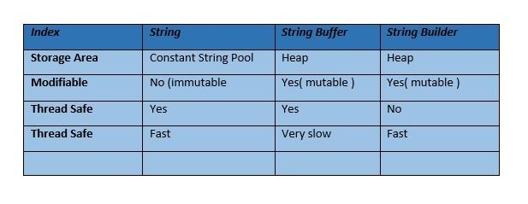
String:-
------
String is immutable ( once created can not be changed )object . The object created as a String is stored in the Constant String Pool .
Every immutable object in Java is thread safe ,that implies String is also thread safe . String can not be used by two threads simultaneously.
String once assigned can not be changed.
Example:-
String demo = " hello " ;
// The above object is stored in constant string pool and its value can not be modified.

demo="Bye" ; //new "Bye" string is created in constant pool and referenced by the demo variable
// "hello" string still exists in string constant pool and its value is not overrided but we lost reference to the "hello"string

StringBuffer ( Thread safe)
---------------
StringBuffer is mutable means one can change the value of the object . The object created through StringBuffer is stored in the heap . StringBuffer has the same methods as the StringBuilder , but each method in StringBuffer is synchronized that is StringBuffer is thread safe .
Due to this it does not allow two threads to simultaneously access the same method . Each method can be accessed by one thread at a time .

But being thread safe has disadvantages too as the performance of the StringBuffer hits due to thread safe property . Thus StringBuilder is faster than the StringBuffer when calling the same methods of each class.

StringBuffer value can be changed , it means it can be assigned to the new value . Nowadays its a most common interview question ,the differences between the above classes .
String Buffer can be converted to the string by using
toString() method.
Example:-
StringBuffer demo1 = new StringBuffer("Hello") ;
// The above object stored in heap and its value can be changed .
demo1=new StringBuffer("Bye");
// Above statement is right as it modifies the value which is allowed in the StringBuffer

StringBuilder (Not a thread safe)
--------------
StringBuilder is same as the StringBuffer , that is it stores the object in heap and it can also be modified . The main difference between the StringBuffer and StringBuilder is that StringBuilder is not thread safe.
StringBuilder is fast as it is not thread safe .
Example:-
StringBuilder demo2= new StringBuilder("Hello");
// The above object too is stored in the heap and its value can be modified
demo2=new StringBuilder("Bye");
// Above statement is right as it modifies the value which is allowed in the StringBuilder

Q> What is static block
Ans :- Static block is used for initializing the static variables. This block gets executed when the class is loaded in the memory. A class can have multiple Static blocks, which will execute in the same sequence in which they have been written into the program.
classJavaExample{
static int num;
static String mystr;
static
{
num = 97;
mystr = "Static keyword in Java";
}
publicstaticvoid main(String args[])
{
System.out.println("Value of num: "+num);
System.out.println("Value of mystr: "+mystr);
}
}

